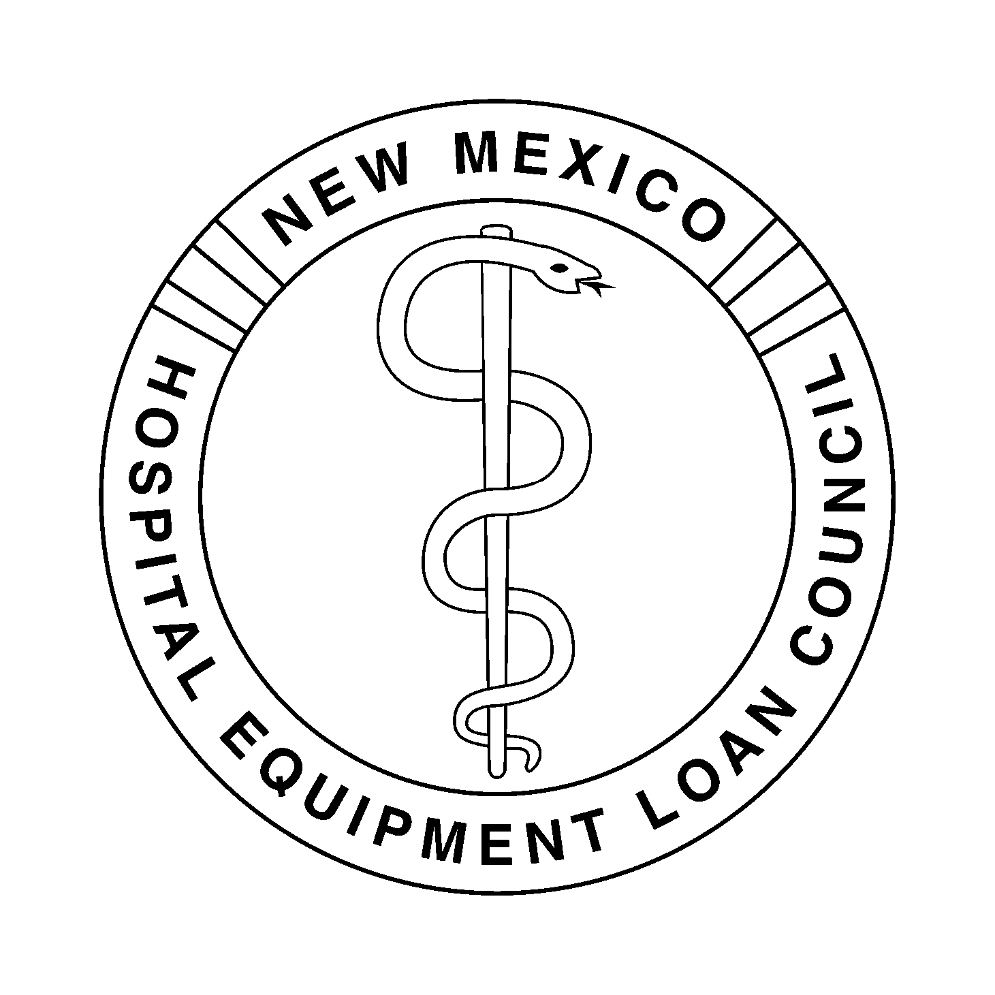
NEW MEXICO HOSPITAL EQUIPMENT
LOAN COUNCIL
February 26, 2015 – 9:00 a.m.
Hospital Services Corporation
Board Room
7471 Pan American Freeway NE
Albuquerque, New Mexico 87109

HSC Wireless Access: HSC_Public Password: nmhsc.com

Dial-In Number: 1-866-906-7447 Pass Code: 1948295#

- Introductions and Welcome |  | Dan Lyon, Chair
- Agenda | Review for Approval of Agenda | Dan Lyon
- Minutes | Review for Approval of Minutes of the November 12, 2014 Meeting (Tab 1) | Christina Campos, Secretary
- Action Items
- Financial Items | - Review for Approval of the NMHELC Independent Financial Audit for the Year Ended June 30, 2014 (Tab 2) | Kent Carruthers, Treasurer, and Jody Belkofer, HSC Controller
 | - Review for Approval of Expenditures for the Quarter Ending December 31, 2014 (Tab 3) | Kent Carruthers and Jody Belkofer
 | - Review for Approval of the Financial Statements for the Quarter Ending December 31, 2014 (Tab 4) | Kent Carruthers and Jody Belkofer
- Discussion Items
- Other Business | - Marketing Opportunities (Tab 5) | Deborah Gorenz, Program Administrator
 | - HELC 2014 Annual Report (Tab 6) | Deborah Gorenz
- Next Meeting | TBD | Dan Lyon
- Adjournment |  | Dan Lyon

Contact: Kristie Bad Warrior, (505) 343-0070 / (866) 908-0070

