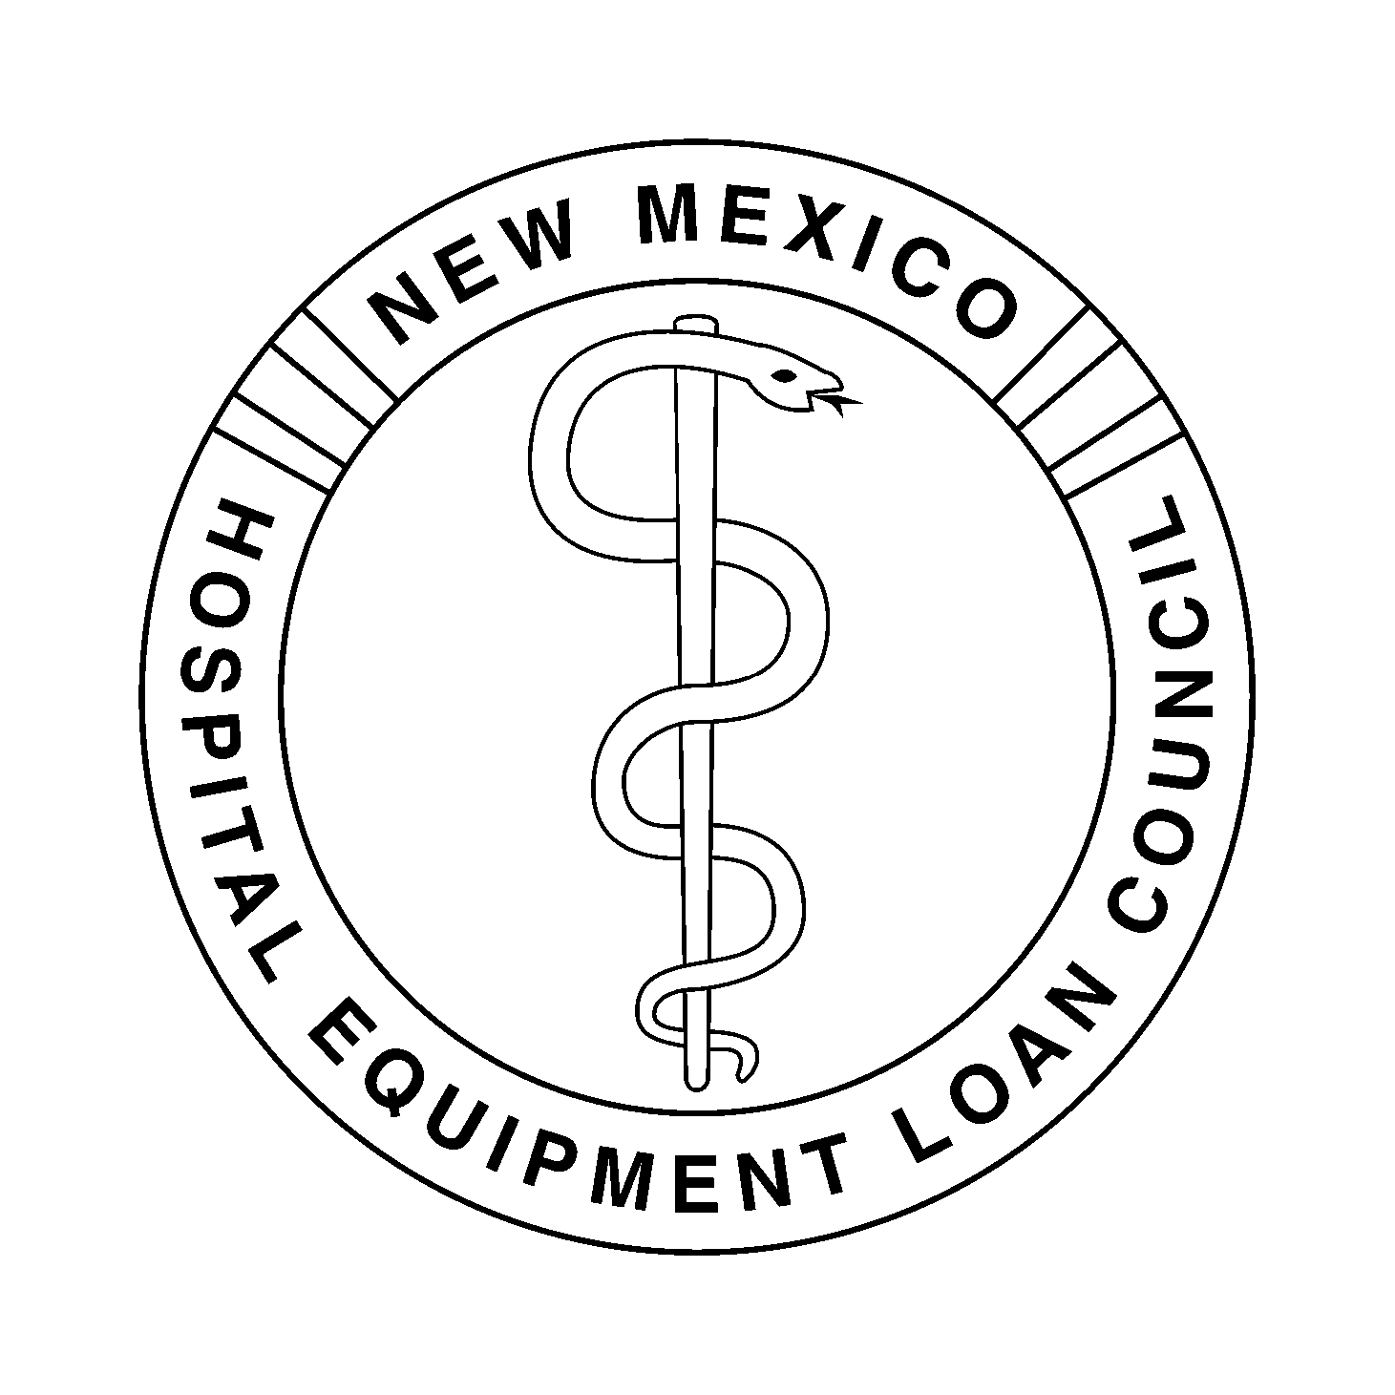
NEW MEXICO HOSPITAL EQUIPMENT LOAN COUNCIL
May 7, 2015 – 4:00 p.m.
Hospital Services Corporation
Board Room
7471 Pan American Freeway NE
Albuquerque, New Mexico 87109

HSC Wireless Access: HSC_Public Password: nmhsc.com

Dial-In Number: 1-866-906-7447 Pass Code: 1948295#

- Introductions and Welcome |  | Dan Lyon, Chair
- Agenda | Review for Approval of Agenda | Dan Lyon
- Minutes | Review for Approval of Minutes of the March 23, 2015 Meeting (Tab 1) | Christina Campos, Secretary
- Action Items | - Presbyterian Healthcare Services Series 2015 Revenue Bonds TEFRA Hearing | Chris Muirhead, General Counsel
 | - Review for Adoption of Sale Resolution, Series 2015 Revenue Bonds, Resolution 169, Presbyterian Healthcare Services (Tab 2) | Chris Muirhead
- Financial Items | - Review for Approval of Expenditures for the Quarter Ending March 31, 2015 (Tab 3) | Jody Belkofer, Controller, HSC
 | - Review for Approval of the Financial Statements for the Quarter Ending March 31, 2015 (Tab 4) | Jody Belkofer
- Other Business | Marketing Opportunities (Tab 5) | Deborah Gorenz, Program Administrator
- Next Meeting | To Be Determined | Dan Lyon
- Adjournment |  | Dan Lyon

Contact: Kristie Bad Warrior, (505) 343-0070 / (866) 908-0070

