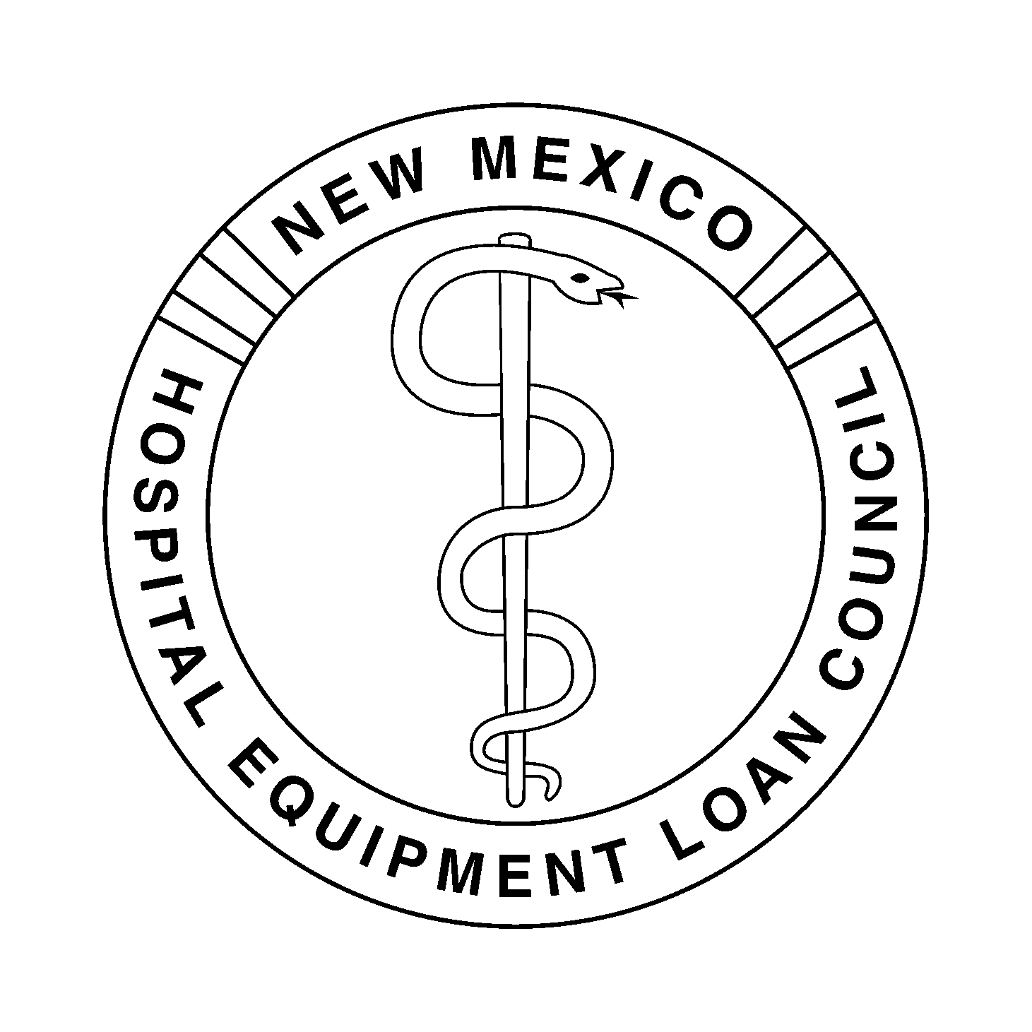
NEW MEXICO HOSPITAL EQUIPMENT
LOAN COUNCIL
November 12, 2014 – 9:00 a.m.
Hospital Services Corporation
Board Room
7471 Pan American Freeway NE
Albuquerque, New Mexico 87109

HSC Wireless Access: HSC_Public Password: nmhsc.com

Dial-In Number: 1-866-906-7447 Pass Code: 1948295#

- Introductions and Welcome | Introduction of New Council Member, Christina Campos, Guadalupe County Hospital | Dan Lyon, Chair
- Agenda | Review for Approval of Agenda | Dan Lyon
- Minutes | Review for Approval of Minutes of the May 8, 2014 Meeting (Tab 1) | Greg Leyendecker, Secretary
- Action Items | - Review for Approval of Resolution for Open Meetings Act for 2014 (Tab 2) | Chris Muirhead, General Counsel
 | - Review for Approval of New Officer Appointments  - Greg Leyendecker to Vice-Chair  - Christina Campos to Secretary | Dan Lyon
- Financial Items | - Closed Session: Exit Conference for Financial Audit (Tab 3) | Jim Macias, CPA, Macias, Gutierrez & Co., PC
 | - Review for Approval of the NMHELC Budget for the Fiscal year July 1, 2014 through June 30, 2015 (Tab 4) | Kent Carruthers, Treasurer and Jody Belkofer, Controller
 | - Review for Approval of Expenditures for the Quarters Ending June 30, 2014 and September 30, 2014 (Tab 5) | Kent Carruthers and Jody Belkofer
 | - Review for Approval of the Financial Statements for the Quarters Ending June 30, 2014 and September 30, 2014 (Tab 6) | Kent Carruthers and Jody Belkofer
- Discussion Items | Review of Investment Policy (Tab 7) | Jody Belkofer
- Other Business | Transaction Inquiries (Tab 8)  - Pending Transactions  - Future Transactions | Deborah Gorenz, Program Administrator
- Next Meeting | TBD | Dan Lyon
- Adjournment |  | Dan Lyon

Contact: Kristie Bad Warrior, (505) 343-0070 / (866) 908-0070

