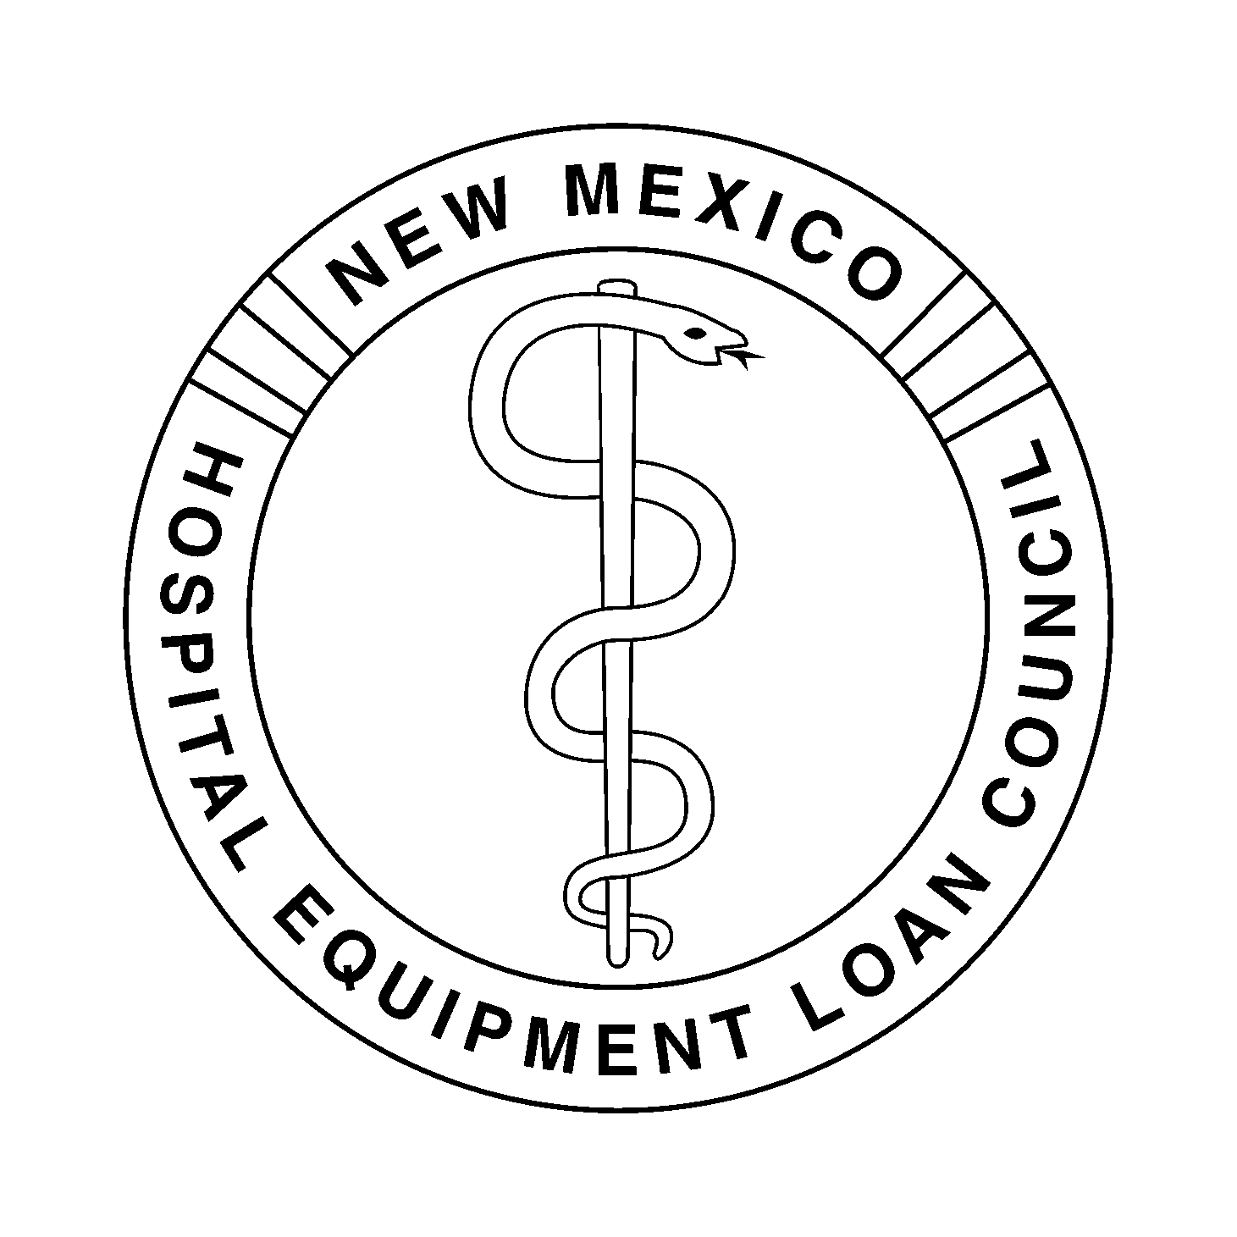
NEW MEXICO HOSPITAL EQUIPMENT LOAN COUNCIL
November 18, 2015 – 9:00 a.m.
Hospital Services Corporation
Board Room
7471 Pan American Freeway NE
Albuquerque, New Mexico 87109

HSC Wireless Access: HSC_Public Password: nmhsc.com

Dial-In Number: 1-866-906-7447 Pass Code: 1948295#

- Introductions and Welcome |  | Dan Lyon, Chair
- Agenda | Review for Approval of Agenda | Dan Lyon
- Minutes | Review for Approval of Minutes of the May 7, 2015 Meeting (Tab 1) | Christina Campos, Secretary
- Action Items | Review for Approval of Resolution for Open Meetings Act for 2016 (Tab 2) | Chris Muirhead, General Counsel
- Financial Items | - Closed Session: Exit Conference for Financial Audit (Tab 3) | Jim Macias, CPA, Macias, Gutierrez & Co., PC
 | - Review for Approval of the NMHELC Budget for the Fiscal year July 1, 2015 through June 30, 2016 (Tab 4) | Kent Carruthers, Treasurer and Jody Belkofer, Controller
 | - Review for Approval of Expenditures for the Quarters Ending June 30, 2015 and September 30, 2015 (Tab 5) | Kent Carruthers and Jody Belkofer
 | - Review for Approval of the Financial Statements for the Quarters Ending June 30, 2015 and September 30, 2015 (Tab 6) | Kent Carruthers and Jody Belkofer
- Discussion Items  - Other Business | - Review of Investment Policy (Tab 7)  - Financial Disclosure Form (Tab 8)  - Rehoboth McKinley Christian Healthcare  Services Forbearance Agreement  Marketing Opportunities (Tab 9) | Jody Belkofer  Deborah Gorenz, Program Administrator  Chris Muirhead  Deborah Gorenz
- Next Meeting | To Be Determined | Dan Lyon
- Adjournment |  | Dan Lyon

